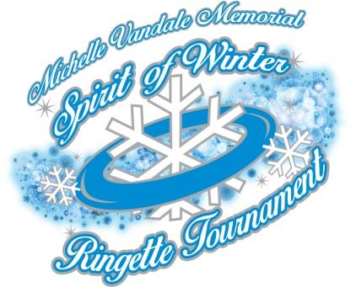

Bill Bettles Memorial Volunteerism
Scholarship Application

Provided by the Michelle Vandale Memorial Spirit of Winter Ringette
Tournament Committee and the Fraser Valley Ringette Association

for ringette players, coaches, on-ice officials, volunteers, and/or executive members

Applications must be received by the Fraser Valley Ringette Association
NO LATER THAN:

November 22nd
(of the current year)

Volunteers are not paid – not because they are
worthless, but because they are priceless...

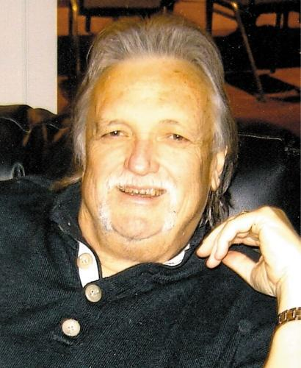

Bill Bettles
Nov. 11th, 1950 – Dec. 26th, 2013

Bill Bettles was a builder of community sports who had a special passion for helping female athletes realize their dreams. Mr. Bettles, a father of three girls, was involved in ringette, girls ice hockey, and softball in Langley, Aldergrove, and the Fraser Valley for three decades.

During his three years as the Township of Langley’s Parks and Recreation Commissioner, Mr. Bettles was instrumental in helping raise funds to develop a lighted park for the Aldergrove Men’s Fast Pitch League. Shortly afterwards, Mr. Bettles became the President of the Aldergrove Ringette Association, where he served for five years, overseeing Aldergrove Ringette's amalgamation with the Langley Ringette Association to become the Fraser Valley Ringette Association. In 1988, he helped start the Lower Mainland Ringette League where he worked closely with the AA ringette program and acted as team manager for many years. Mr. Bettles was also a coach and administrator with the Langley Girls' Fast Pitch Association and founder of the first ice hockey association for female athletes in Langley in 1995, the Langley Girls' Ice Hockey Association, and he served as its first President.

In 2009, believing that women athletes should not have to pay thousands to play a competitive sport, Mr. Bettles started and served as General Manager of the National Ringette League's British Columbia entry -- the Fraser Valley Avalanche. This initiative became Canada's first fully-funded ringette program, with athletes’ travel and team fees fully covered.

Mr. Bettles was inspired to endow the Fraser Valley Ringette Association’s Michelle Vandale Memorial annual scholarship award in memory of Michelle Vandale who was a tireless volunteer, athlete, coach and ringette enthusiast of the Fraser Valley Ringette Association. The Bettles family continues to support the fund and participates in scholarship committee selections annually.

In 2011, Bill Bettles was the recipient of a Community Sport Builder Award from Pacific Sport Fraser Valley for his many accomplishments and contributions to amateur sports.
PURPOSE OF THE BILL BETTLES VOLUNTEERISM SCHOLARSHIP

To provide annually a scholarship of $500 towards post-secondary education for ringette players, coaches, executive members, volunteers, and/or officials who demonstrate strong academic performance, a sustained strong commitment to the sport of ringette, and who emulate the passion and dedication that Bill Bettles had for his community by actively volunteering in sport or community.

In addition to the financial award, recipients will receive a scholarship award certificate and have their name on a perpetual plaque displayed in one of the Langley area ice arenas.

WHO IS ELIGIBLE?

- Application for the Bill Bettles Volunteerism Scholarship may be made by ringette participants (male or female) who are registered, and in good standing, with one of Ringette Canada’s provincial/territorial member associations as any of the following:

- Ringette players and/or
- Ringette coaches who are certified or in the process of becoming certified and/or
- Active on-ice ringette-certified officials, and/or
- Volunteers

- Applicants must have demonstrated a commitment to their education and must meet the admission standards of the educational institution or program specified.

- Applicants must be actively volunteering in community and/or sport.

- Applicants may be either male or female, be any age provided that they are in their final year of high school or first year of post-secondary education and will be enrolled full-time in a recognized post-secondary training program, college, or university in the following academic year.

- The chosen applicant will be someone who has been a positive role model in his/her community or sport, who best demonstrates sustained commitment, dedication and passion for the sport of ringette through playing, coaching, officiating and/or other volunteer activities, and who is committed to giving back to his/her community and/or sport through continued volunteer work.

APPLICATION PROCEDURE

Applications (plus supporting documents as detailed below) must be forwarded on or before Nov. 22nd to:

Mail Option:  Fraser Valley Ringette Assoc.  Scholarship Committee  P.O. Box 61591  Langley, BC, V3A 8C8 | Email Option:  tournaments@fvringette.com  AND  scholarships@fvringette.com  Subject Line: BB Scholarship
NOTIFICATION

The Fraser Valley Ringette Association and the Bill Bettles Volunteerism Scholarship Committee reserve the right to choose not to award the scholarship if the pool of candidates does not meet the criteria outlined or if there are no applicants. The name of the successful applicant will be announced at the U19 Gold Medal game during the Michelle Vandale Memorial Spirit of Winter Ringette Tournament with written confirmation to follow.

Please be sure that the following items are included in your scholarship application package:

The scholarship application form (pages 5, 6, 7 and 8), fully completed. | ❑
Three (3) current letters of reference from people (not relatives) highlighting your volunteerism in sport or community. | ❑
A transcript of marks for the last completed year of your education. | ❑
Proof of registration as an active player, coach, volunteer, or on-ice official for the current ringette playing season. | ❑

IMPORTANT NOTE: Scholarship funds will not be released by Fraser Valley Ringette Association until confirmation of the successful applicant’s full-time enrollment in an appropriate post-secondary educational institution or program for the academic year following which the scholarship was awarded and proof of grades for the current academic year has been received. Scholarship funds must be applied to the academic year following which the scholarship was awarded.

Bill Bettles Volunteerism Scholarship Application Form

DATE:
Personal/Contact Information
First Name | Last Name
Home Address
City | Province | Postal Code
Telephone | Email
Ringette Registration
Name of your current ringette association
Name of your current team (if applicable)
Division | City | Province
Academic Information
Current High School or Post-Secondary Institution
Name of Institution
City/Province | Postal Code | Telephone
Current Grade/Level of Study | Average Grade % | Expected Graduation (mm/yy)

Post-Secondary Educational Institution planning to Attend next year
Name of Institution
City |  |  |  | Province |  | Postal Code
Telephone |  |  |  | Fax |  | Expected Graduation (mm/yy)
Program/Major Area of Study |  |  |  |  |  | Duration of Program (years)
Ringette Résumé
Year | Team | Division |  |  | City |  | Accomplishments/Memories
2011 | Fraser Valley Vipers | U19 A |  |  | Langley |  | Heart & Soul Award, Team went to AB
Other notes about your ringette career:
Officiating: |  |  | Officials certification number (if known):
Coaching: |  |  | Coaches certification number (if known):
Other Volunteer Activities (Ringette, School, Community):

Volunteerism and You
Please explain how you emulate the Bill Bettles Volunteerism Scholarship.
(Maximum 1000 words).

STATEMENT OF ACCURACY

I hereby affirm that the above stated information provided by me is true and correct to the best of my knowledge. I also consent that my picture may be taken and used for any purpose deemed necessary to promote the Bill Bettles Volunteerism Scholarship.

I hereby understand that if chosen as a scholarship recipient, I must provide a copy of my transcript (marks) for the current academic year as well as evidence of acceptance to a post-secondary institution or program of my choosing for the next academic year prior to the scholarship funds being awarded.

Applicant’s Signature:__________________________________Date:_______________

